**Background**

Robust data on discounting and concessions has long been absent in the world of apartment data and analytics. An extensive set of data collected by CoStar Group since the beginning of 2015 is starting shed some light on what can be an important barometer of leasing competition.

The higher the prevalence of concessions, the more difficult it is for property managers to command rent hikes on residents with a broad array of attractive deals at other potential rental properties. While outside the scope of this analysis, the rise and fall of concessions almost universally goes hand-in-hand with decelerating and accelerating rent growth.

CoStar has about 20 million ‘effective rent’ observations going back to the start of 2015. These observations are collected by a team of ‘mystery shoppers’, which calls apartment communities as if they were renters. Callers ask for the rent (or rents) for a specific size of unit, such as one-bedrooms, or two-bedrooms. They also ask if the property is offering any deals or discounts.

Discounts offered by apartment communities can vary significantly. They can be something like a waived application fee, or a loftier discount such as a month’s free rent. This paper looks at the frequency of discounts that directly impact the rent. This could be a $500 one-time discount, a $100 per-month reduction over the entire course of the lease, or two-months of rent free upfront.

In the state of Colorado, CoStar has around 300,000 of these rent observations going back to the start of 2015. The five largest metro areas in Colorado (listed below) have sufficient data to analyze concession trends on both a monthly and yearly basis.

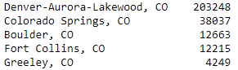

The callers who collect these availabilities select one of the following options to represent the concession. If one of the highlighted buttons is selected, the availability is tied to *some* level of a rent conession. The frequency of these concessions (out of all available apartments) will be examined throughout this report



**Questions to be addressed:**

*1. How have concessions trended in the State of Colorado from 2015-Present?*

* *How does that vary depending upon the metro area?*

*2. Examine Seasonality: Which months have the highest concession frequency?*

*3. Are concessions significantly different when excluding new construction?*

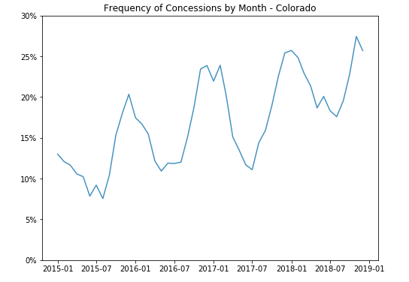First, a look at the frequency of rent discounts in the state of Colorado on a monthly basis, from 2015 to year-end 2018.

Concessions are clearly trending upwards, but one takeaway from the graph is the **high degree of seasonality**: Concessions are much more frequent in the slower winter leasing season, and far less frequent in the active summer leasing season.

A look at the frequency of rent discounts by month (using full year data from 2015 through 2018) sheds more light on this result—pictured below.

Concessions are significantly higher in October through March, and significantly lower in the summer, bottoming out in the June-August three-month period.

Separate analysis has shown that more than two-thirds of apartment absorption occurs in the 2nd and 3rd quarters (April through September. Slower leasing activity in the winter understandably increases the impetus for offering discounts

**Interpreting these numbers:** Using December as an example: Out of all available apartments in the state of Colorado during the month of December, 24% were tied to some sort of rent concession. In July, Discounts were approximately half as frequent.

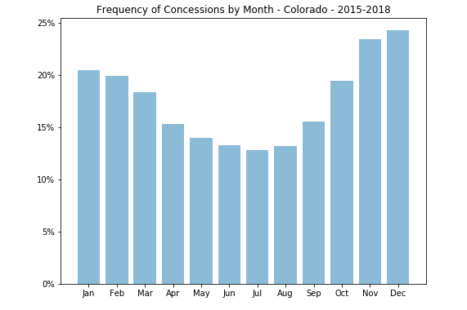

**Comparing concession activity across different metro areas.**

Here, a tool was made to examine concession trends in certain metro areas, compared to the State of Colorado as a whole. To correct for seasonality, this analysis uses full-year data (the frequency of rent concessions over the course of an entire year).

Commentary on development, economic, or other factors that may explain the trends are discussed for each metro.

**Colorado Springs**

* Colorado Springs did not see development take off in earnest until the second half of 2017, making it the last major Front Range metro to see a significant wave of apartment development this economic cycle. Concessions were trending downward through the start of 2017, but have since become far more frequent as development finally picked up in earnest.

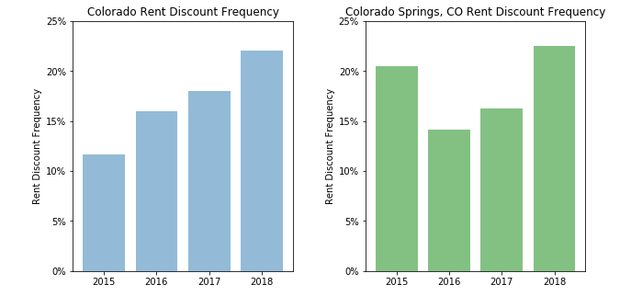

**Denver**

* Denver has seen significant development throughout this cycle, and in 2016 faced additional headwinds from a sustained drop in oil prices that led to significant downsizing in that sector. A rebound in economic growth in 2018 wasn’t enough to offset historical levels of new development

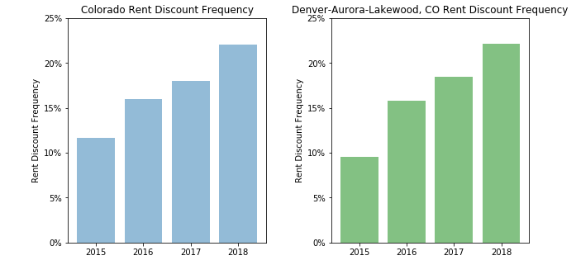

**Greeley**

* In Greeley, oil and gas employment as a percentage of total employment is similar to Houston, and this metro faces by far the most relative exposure to headwinds in that sector. The frequency of rent concessions more than doubled in 2016, then fell significantly as the oil and gas sector stabilized

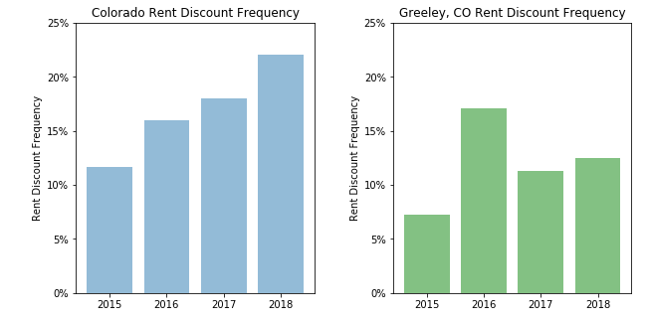

**Fort Collins**

* In percentage terms, the Fort Collins metro has seen more development over the past year than all but one of the 200 largest metro areas in the US. The current construction pipeline remains massive, and the leasing environment is likely to remain highly competitive for landlords (and attractive for renters) for at least another year.

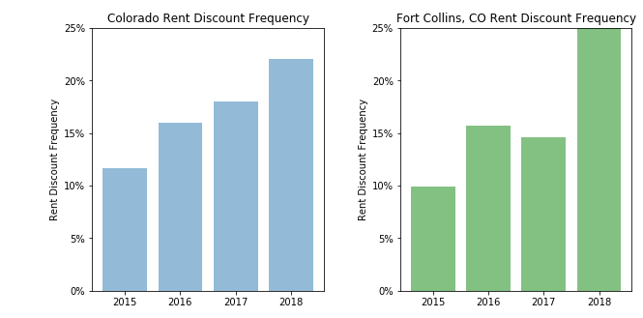

**Boulder**

* Concessions jumped significantly in the aftermath of a supply wave that stretched from 2014 through 2015. A moratorium on building heights passed in late 2015 (and subsequently extended twice, most recently through 2020) has all but shut off development in the city of Boulder proper, and the leasing environment has become far more favorable over the past two years.

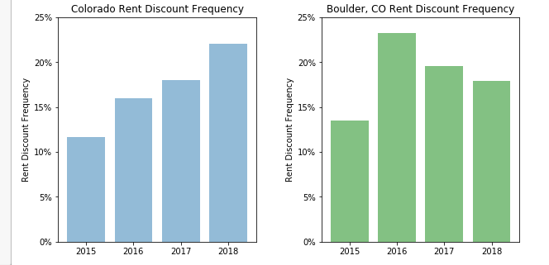

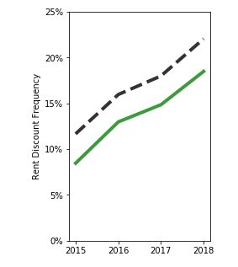**Impact of New Construction**

Previous analyses in this report look at the frequency of rent concessions out of *all* available apartments. New construction, especially developments in lease-up tend to offer substantially higher levels of discounting. With this in mind, it’s worthwhile to view what concessions look like in the absence of new construction.

For all available apartments, the frequency has increased from 11.7% in 2015 to 22.1% in 2018, or an 89% increase

**Excluding 2010-present construction**, the frequency has increased from 8.5% in 2015 to 18.5% in 2018, or a 118% increase.

**Future analysis**

The data in this sample can be manipulated to calculate the actual concession percentage, rather than the frequency of concessions. The calculation to come up with the actual percentage depends on which type of concession is selected below. For a given concession type, the calculation is always the same, so this is a feasible exercise. This would allow vision into the magnitude of concessions. For example, concessions of at least one-month’s free rent (>=8.3%) , and especially those exceeding one-month’s free rent (>8.5%) can act as telling barometers on leasing competition.

